TRAINING COURSE ON EDIBLE AND MEDICINAL MUSHROOMS

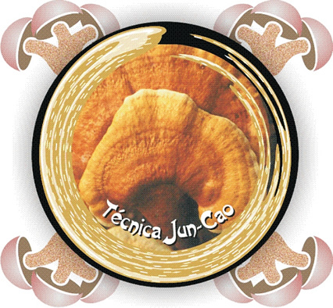

Period: September, 18 to 20, 2014

Technical coordination:

Arailde Fontes Urben
Maame Obodai

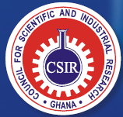


Ghana - Africa
2014

Day 1 - Thursday (09/18/2014)
Morning (lectures)

08:00 – 08:15 | Distribution of course material
08:15 – 08:30 | Opening the training course
08:30 – 08:45 | Presentation of students
08:45 – 09:30 | General notions of mushrooms - Dr. Arailde Fontes Urben
09:30 – 10:00 | Coffee break
10:00 – 11:30 | Formulation and preparation of culture medium, "seeds" and cultivation substrate - Prof. Edison de Souza
11:30 – 13:30 | Lunch

Afternoon (practical classes)

13:30 – 15:00 | Formulation, preparation and inoculation of culture medium - Prof. Edison de Souza and Dr. Arailde Fontes Urben
15:00 – 15:30 | Coffee break
15:30 – 17:30 | Formulation, preparation and inoculation of "seeds" - Prof. Edison de Souza and Dr. Arailde Fontes Urben

Day 2 - Friday (09/19/2014)
Morning (lectures)

08:00 – 09:30 | Mushroom cultivation by Juncao technique - Dr. Arailde Fontes Urben
09:30 – 10:00 | Coffee break
10:00 – 11:30 | Cultivation of Pleurotus spp. - Prof. Edison de Souza
11:30 – 13:30 | Lunch

Afternoon (practical classes)

13:30 – 15:00 | Formulation, preparation and inoculation of culture substrates – (Part I) - Prof. Edison de Souza and Dr. Arailde Fontes Urben
15:00 – 15:30 | Coffee break
15:30 – 17:30 | Formulation, preparation and inoculation of culture substrates - (Part I) - Prof. Edison de Souza and Dr. Arailde Fontes Urben

Day 3 - Saturday (09/20/2014)

Morning (lectures)

08:00 – 09:15 | Cultivation of Lentinula edodes - Dr. Arailde Fontes Urben
09:15 – 10:30 | Cultivation of Agaricus blazei - Prof. Edison de Souza
10:30 – 10:45 | Coffee break
10:45 – 12:00 | Cultivation of Ganoderma lucidum - Dr. Arailde Fontes Urben
12:00 – 13:30 | Lunch

Afternoon (lectures)

13:30 – 14:30 | Diseases and pests and their control - Dr. Arailde Fontes Urben
14:30 – 15:00 | Coffee break
15:00 – 16:00 | E Economi Economical aspects of fungiculture: Processing and marketing - Prof. Edison de Souza
16:00 – 18:00 | Functional mushrooms and their importance in human health - Dr. Arailde Fontes Urben
18:00 - 18:30 | Closing

